Bài tập tuần 4

Bài 1:

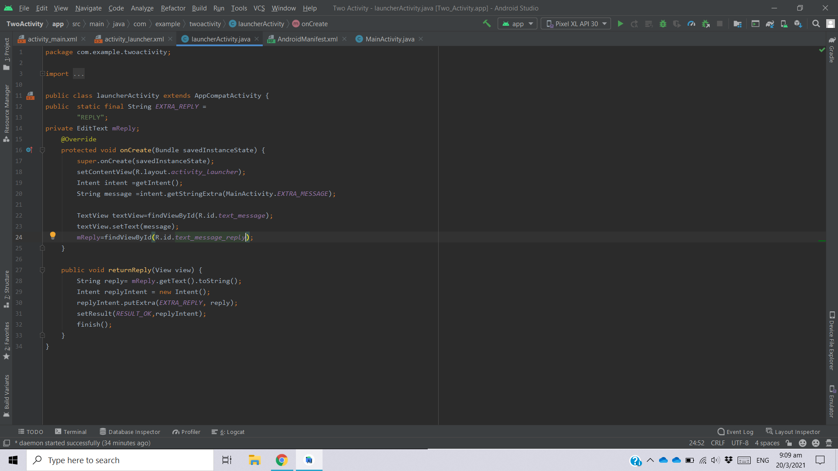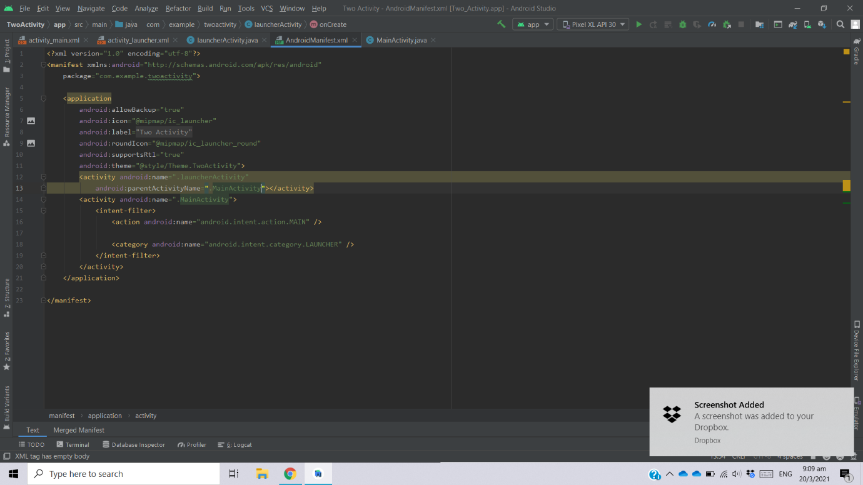

Bài 2: Coding Challenge

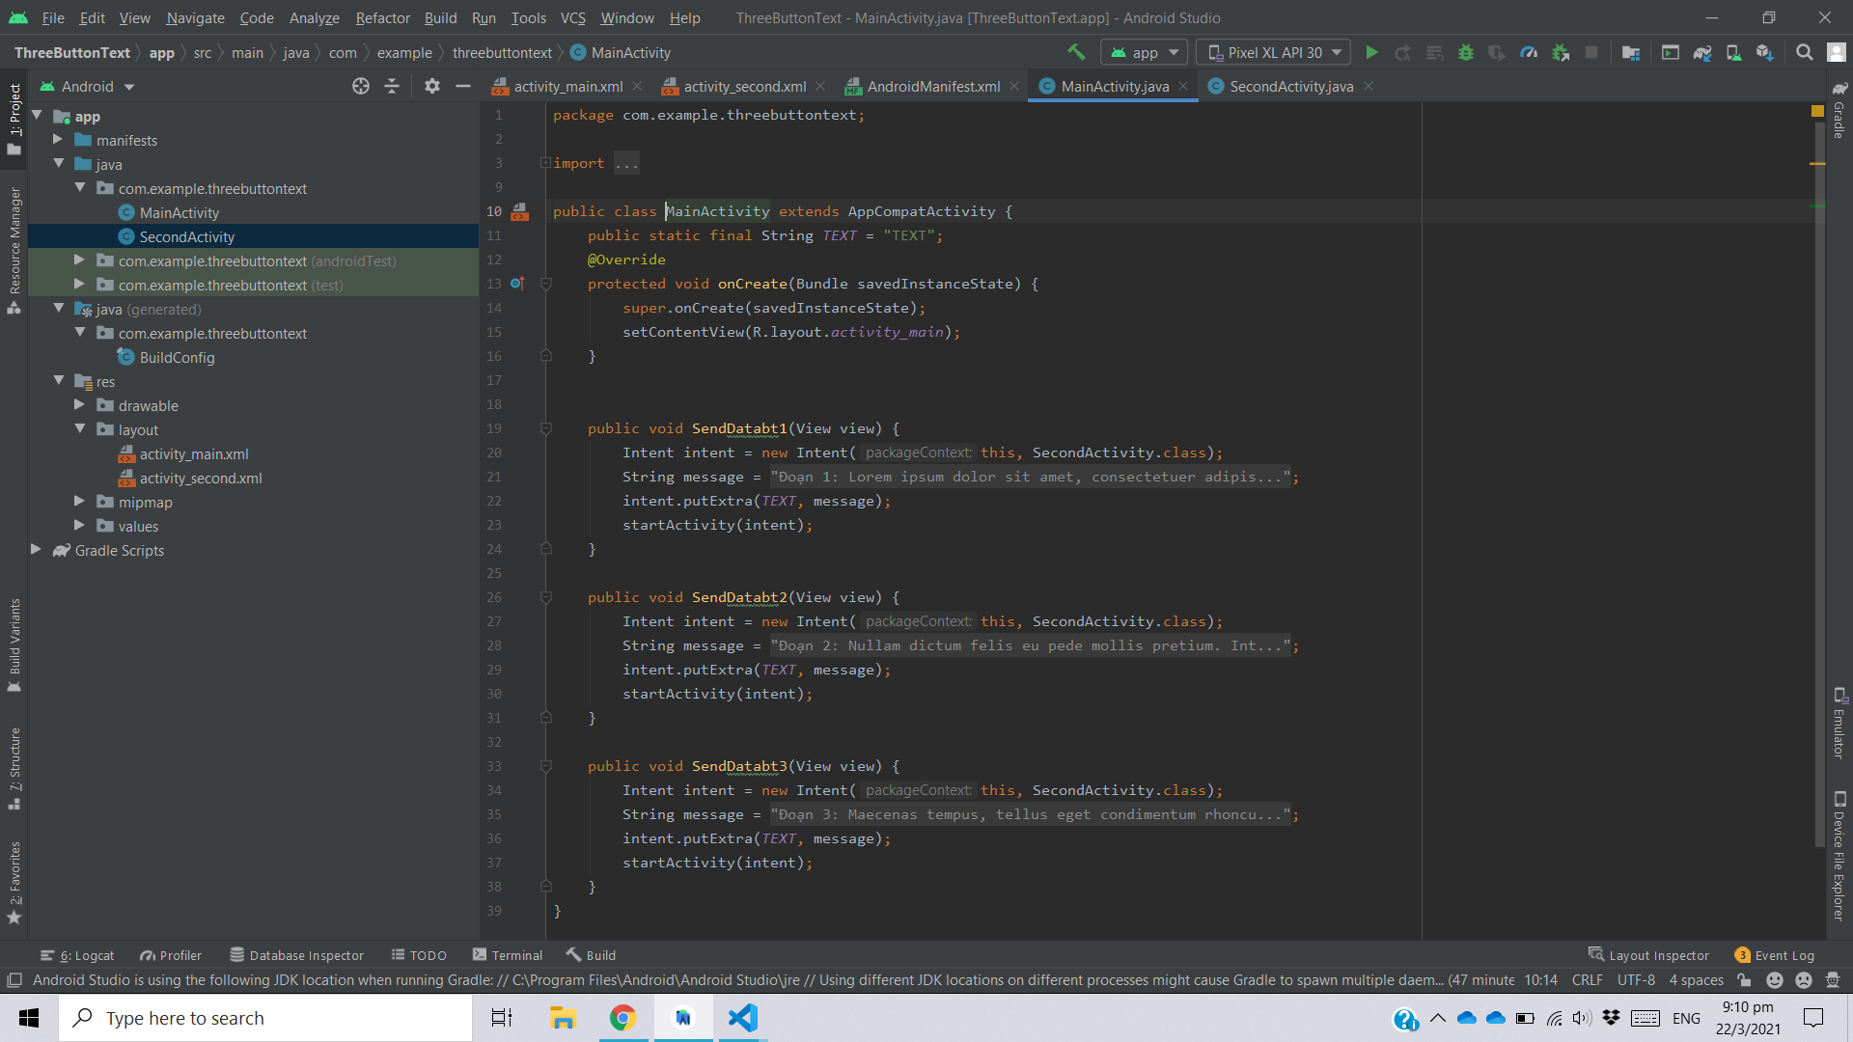

Main Activity

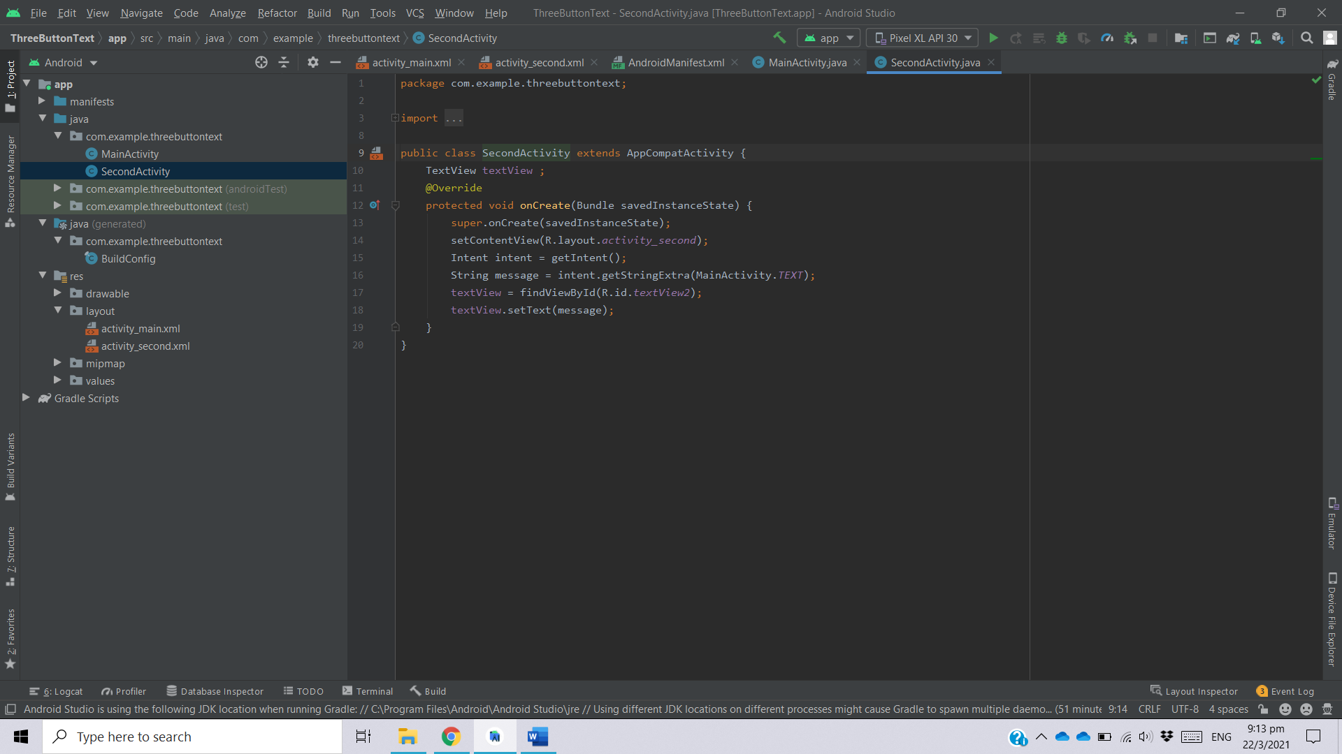

Second Activity

Bài 3: Hello Toast

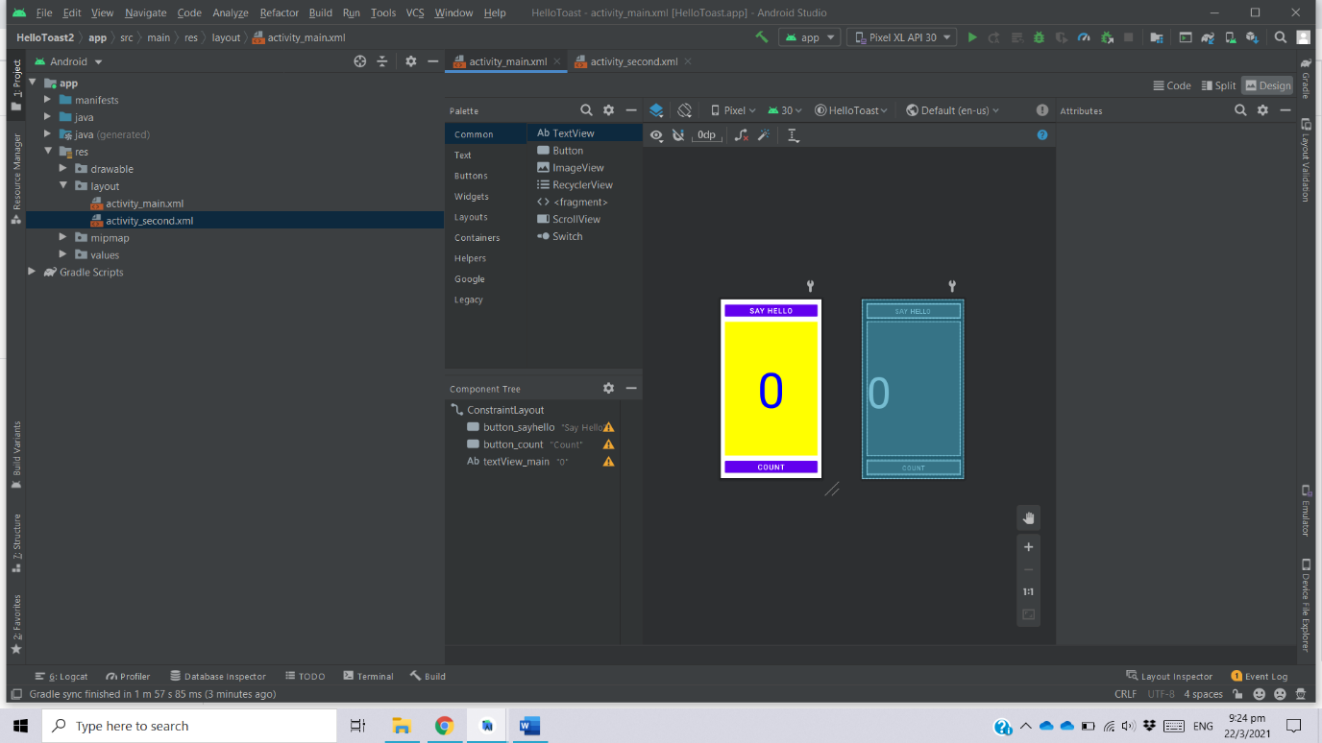

Giao diện main

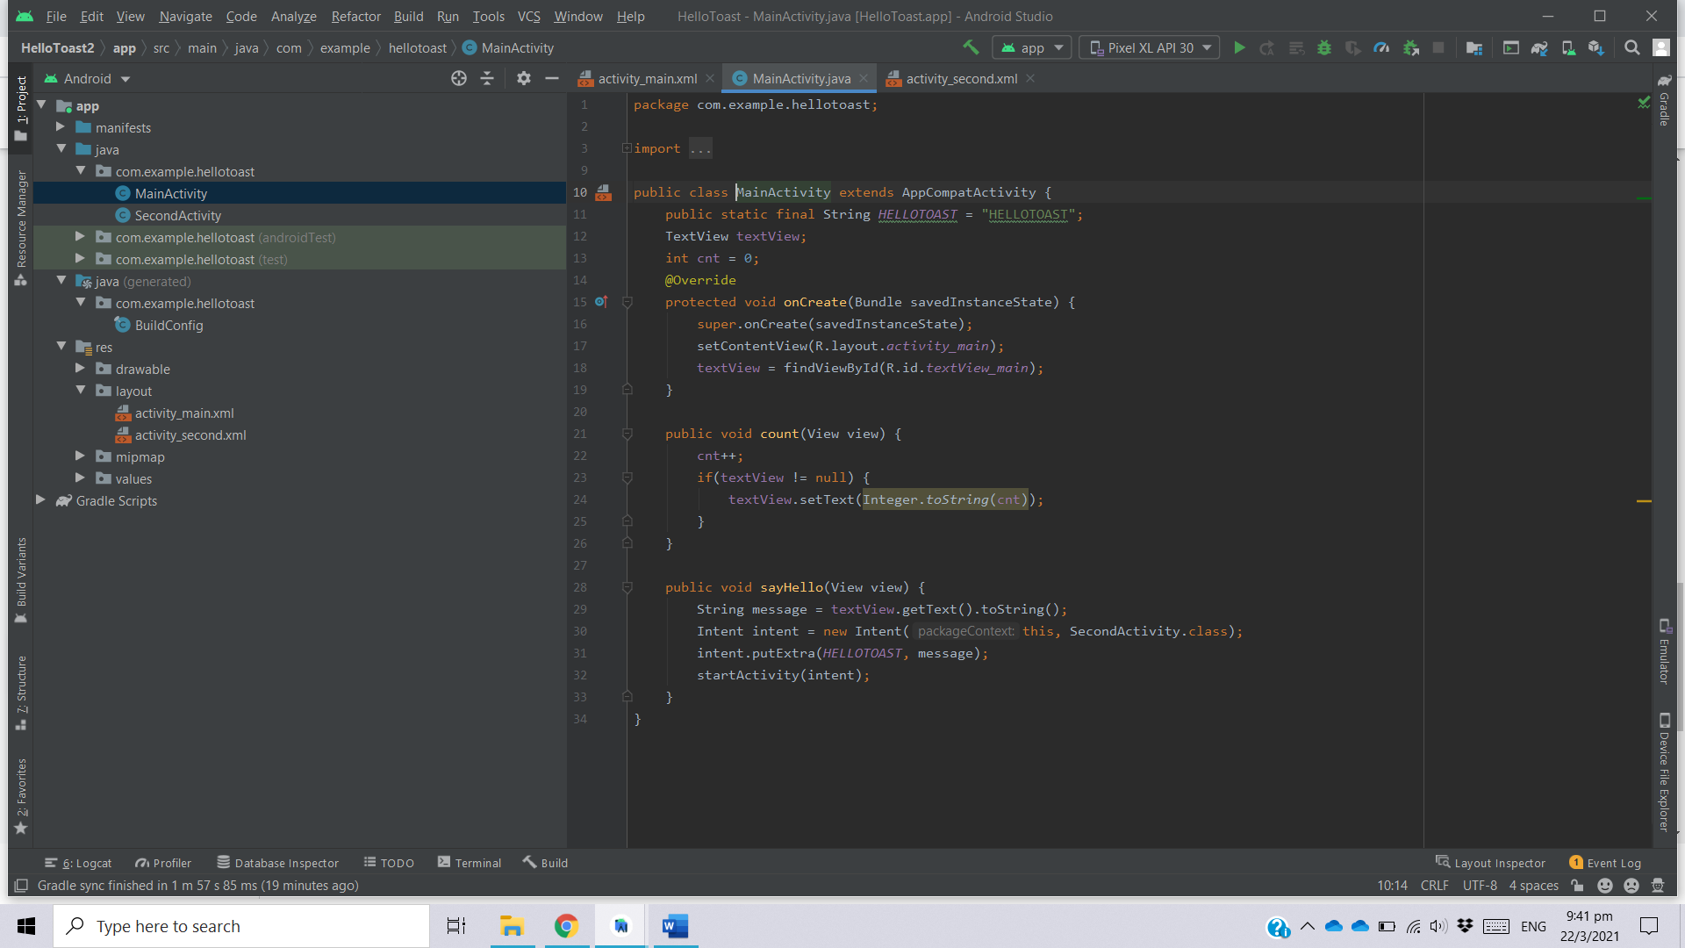

Main Activity

Trả lời câu hỏi:

1. What changes are made when you add a second Activity to your app by choosing **File > New > Activity** and an Activity template? Choose one:

* The second Activity is added as a Java class, the XML layout file is created, and the AndroidManifest.xml file is changed to declare a second Activity.

1. What happens if you remove the android:parentActivityName and the <meta-data> elements from the second Activity declaration in the AndroidManifest.xml file? Choose one:

* The second Activity no longer appears when you try to start it with an explicit Intent.

1. Which constructor method do you use to create a new explicit Intent? Choose one:

* new Intent(Context context, Class<?> class)

1. In the HelloToast app homework, how do you add the current value of the count to the Intent? Choose one:

* As the Intent TEXT_REQUEST

1. In the HelloToast app homework, how do you display the current count in the second "Hello" Activity? Choose one:

* All of the above.